Time Marches On
Heber Valley Quilters
2011 Block of the Month

August—French Forest Block
World War I, from 1914-1918, was known as the Great War before WWII happened as it was supposed to be the war to end all wars. 70,000,000 men and women in uniform from all over the world were involved in WWI, and of that number one-half were either killed, wounded or became prisoners of war.
The Battle of Belleau Wood in June of 1918 was a pivotal point in the war and in U.S. Marine History. Stars of David and Latin crosses mark the resting places of 2000 U.S. soldiers in the cemetery near Belleau, France. After the battle, the French renamed the wood "Bois de la Brigade de Marine" ("Wood of the Marine Brigade") in honor of the U.S. Marines' tenacity. Belleau Wood is allegedly also where the Marines got their nickname "Teufelshunde", roughly translated as "Devil Dogs", because of the ferocity with which they attacked. General Pershing, Commander of the U.S. Armed Forces, said "The deadliest weapon in the world is a Marine and his rifle!" Pershing also said "the Battle of Belleau Wood was for the U.S. the biggest battle since Appomattox (the last battle of the American Civil War) and the most considerable engagement American troops had ever had with a foreign enemy."
The Battle of Argonne Forest in the fall of 1918 was a huge victory for the British, French, American, and Imperial Allied Forces but resulted in 117,000 American casualties. They are buried in an American cemetery in France, marked with crosses. This month’s quilt block is called ‘French Forest’ in honor of those that served and gave their all in the French and Belgium forests and country sides in the Great War, WWI.
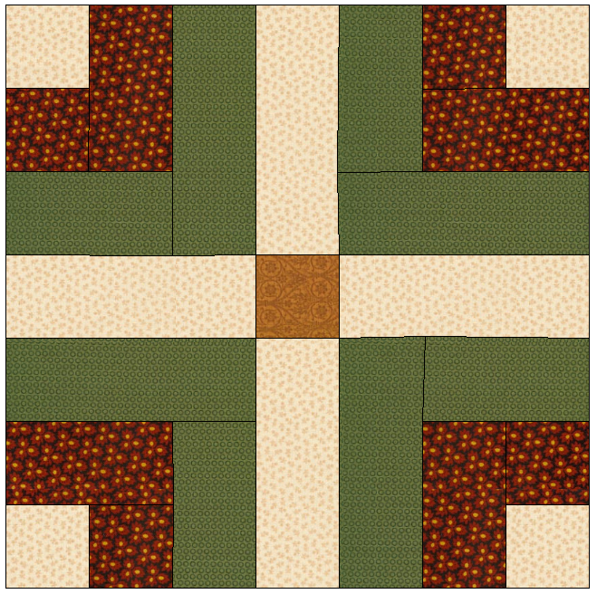
Make 1 – 12” finished (12 ½” unfinished) size block.

Cutting
Fabric A (gold)—1 – 2 ¼” square
Fabric B (red)—4 – 2 ¼” squares, 4 – 2 ¼” x 4” rectangles
Fabric C (green)—4 – 2 ¼” x 4” rectangles, 4 – 2 ¼” x 5 5/8” rectangles
Background fabric—4 – 2 ¼” squares, 4 – 2 ¼” x 5 5/8” rectangles
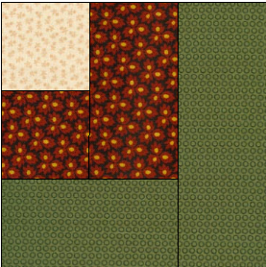
Block Construction
- The units of this block will be constructed in a log cabin fashion. Refer to picture at right for placement of the following pieces: 1 Background 2 ¼” square; Fabric B 1 – 2 ¼” square and 1 – 2 ¼” x 5 5/8” rectangle; and Fabric C 1 – 2 ¼” x 4” rectangle and 1 – 2 ¼” x 5 5/8” rectangle.
- Stitch Background square to Fabric B square. Press towards Fabric B. Return segment to its place in layout.
- Stitch Fabric B rectangle to segment stitched in step 2. Press towards Fabric B. Return segment to its place in layout.
- Stitch Fabric C 2 ¼” x 4” rectangle to segment stitched in step 3. Press towards Fabric C. Return segment to its place in layout.
- Stitch Fabric C 2 ¼” x 5 5/8” rectangle to segment stitched in step 4. Press towards Fabric C.
- Repeat steps 1 to 5 three more times with remaining Background squares, Fabric B and C rectangles to yield 4 corner units measuring 5 1/8” square finished size (5 5/8” square unfinished).
- Referring to picture of block, layout Background rectangles, Fabric A square and corner units. Pay careful attention to placement of units. Background square of each unit is outside corner of block.
- Stitch upper left unit to background rectangle. Press towards unit. Stitch upper right unit to opposite side of background rectangle. Press towards unit. This becomes row 1.
- Stitch background rectangles to opposite sides of Fabric A square. Press towards Fabric A square. This becomes row 2.
- Stitch lower left unit to background rectangle. Press towards unit. Stitch lower right unit to opposite side of background rectangle. Press towards unit. This becomes row 3.
- Stitch rows together. Press towards rows 1 and 3.

